|  |  |
| --- | --- |
| REPORT FOR: | OVERVIEW AND SCRUTINY COMMITTEE AND SCRUTINY SUB-COMMITTEES |
| Date of Meeting: | 12 February 2019 |
| Subject: | Fly Tipping |
| Responsible Officer: | Paul Walker – Corporate Director of Community |
| Scrutiny Lead Member area: | Councillor Ghazanfar Ali (Co-Chair, Scrutiny Lead Member for Community)  Councillor Jean Lammiman (Co-Chair, Scrutiny Lead Member for Community) |
| Exempt: | No |
| Wards affected: | All |
| Enclosures: | Appendix 1: Breakdown of actions taken by London Boroughs in 2017-18 |

|  |
| --- |
| Section 1 – Summary and Recommendations |
| This report sets out an overview of fly tipping and the current and future actions being taken to address it in the Borough Recommendations: To note the report |

# Section 2 – Report

**2.1 National and Local Picture**

2.1.1 Fly-tipping is defined as the illegal deposit of waste on land contrary to Section 33(1) (a) of the Environmental Protection Act 1990. The types of waste fly tipped range from 'black bag' waste to large deposits of materials such as industrial waste, tyres, construction material and liquid waste.

2.1.2 Local Authorities are required to report fly tipping actions and incidents to the Department for Environment, Food and Rural Affairs (DEFRA) on an annual basis, to provide a national overview.

2.1.3 In 2017/18, nationally and Harrow picture of fly tipping was:

* 998,000 incidents, down 1% from the previous year
* Harrow has seen a 40% increase in the same period
* 66% of all fly tips were classed as “household black bags / other”
* Harrow was 65% household waste
* 69,000 FPNs issued (but 52% were in relation to littering, 11% for fly tips, 37% other issues)
* 46% occurred on the highway, 16% on Council Land, 11.6% in back alleyways and only 1.4% on private residential premises
* Harrow had 72% on Highways, 3% Council Land, 1.75% back alleyways and 0.44% on private residential premises
* Only 7% of fly tips reported nationally were linked to commercial waste
* 4% in Harrow were linked to commercial waste
* 64% of all action taken is classed as “investigation”, 9% being warning letters and 8% duty of care visits and only 0.22% of all fly tips led to a prosecution (these do not take into account FPNs)
* 85% of Harrows actions were investigation, 4.7% warning letters and 5.5% Duty of Care

## 

## 2.2 Drivers for change

2.2.1 Extensive research has been carried out in relation to the socio, economic and political effect of fly tipping, including work by the Jill Dando Institute[1]. This particularly explored the increased fear of crime associated with increased / persistent fly tipping. There are many reasons to develop an operational plan for tackling fly-tipping, but the four main drivers for change are:

* **Environmental, social and financial impact** – As mentioned above, the council recognises the unacceptable environmental and social harm caused by fly-tipping. Fly-tipping presents a particular financial burden on the council. These are monies that could be better directed towards more essential services such as school places, adult social care and housing.
* **Current changes to waste disposal** – these include charging for garden waste disposal, greater demand on the civic amenity site as a result of neighbouring boroughs closing their facilities.
* **Working in isolation** – the current approach to tackling fly-tipping is fragmented. The council wants to develop a holistic approach in Harrow.
* **Perception** – fly tipping has an adverse effect on how a person feels around living, working or visiting an area. It ties in with how a person perceives pride in their area, and happiness in it. It unfortunately can cause the same issues as that seen by the broken window effect[2]

**2.3. Responsibilities**

2.3.1 Defra is responsible for the national steer on tackling fly-tipping, with enforcement and investigation split between local authorities and the Environment Agency.

2.3.2 The Environment Agency oversees large scale fly tips. These are defined as more than a lorry load, being approximately greater than 20m3, fly tips by organised gangs / group of offenders, or fly tips that involve hazardous waste[3]

2.3.3 Local Authorities are responsible for dealing with investigating, clearing and taking appropriate enforcement action in relation to smaller scale fly tips on public land. They do not have a responsibility to clear fly tips from private land, and this rests with the landowner. The removal of fly tips from private land must be carried out by the landowner in compliance with the legislation, including ensuring any waste is taken away from an authorised waste carrier.

2.3.4 Defra has published information[4] regarding this responsibility, stating:

“*Neither the local authority nor the Environment Agency is under any legal obligation to remove the waste. Placing a duty on the authorities to remove all waste from private land would simply encourage illegal dumping rather than tackle the problem. People would not pay the costs of legitimate disposal if they knew they could fly-tip it in the nearest field and the local tax payer would foot the bill*”

## 2.4 Legislation

2.4.1 The Environmental Protection Act 1990 as amended is the principal piece of legislation. The offence of fly-tipping and the additional offences of ‘knowingly causing’ or ‘knowingly permitting’ fly-tipping are set out in Section 33(1) (a)

2.4.2 There is also a “duty of care” on businesses under **Section 34** of the Act, being a legal responsibility to ensure that they produce, store, transport and dispose of their business waste without harming the environment.

2.4.3 Until May 2016, the penalties for fly tipping were informal warnings, a simple caution or prosecution. A prosecution for fly tipping can result in a fine of up to £50,000 or 12 months imprisonment in a Magistrates Court, or unlimited fine and up to 5 years imprisonment if convicted in a Crown Court. Additionally, there is the power to seize vehicles and / or its contents because of involvement in fly tipping.

2.4.4 Courts can also make guilty offender pay for all court and investigation costs that enforcement agencies had to pay in bringing action to court, as well clean-up costs of the public authority and landowners.

2.4.5 There are powers under the Cleaner Neighbourhoods and Environment Act 2005 to seize and forfeit any vehicle used in fly tipping, as well as stop and search vehicles (in the presence of Police) for fly tipping and waste duty of care checks (e.g. carrying waste while not registered)

2.4.6 In May 2016, the Government introduced new legislation being the Unauthorised Deposit of Waste (Fixed Penalties) Regulations 2016, which brought in fixed penalties for small scale fly tips. These FPNs can be set at a local level - £150 to £400. A London wide approach to setting a consistent fee is being adopted.

2.4.7 Appendix 1 shows a breakdown of actions taken by London Boroughs in 2017-18. Some caution must be given as the Fixed Penalty aspect includes all FPNs issued and not just for fly tipping. These figures are from

## 2.5 Factors that contribute to fly-tipping in Harrow

2.5.1 While there is no definitive answer, there are a number of factors that the council view as could be contributing to the problem including:

* The cost of dealing with waste has increased providing a greater opportunity for rogue traders to find illegal ways to dispose of waste.
* Increased HMOs (72% increase in HMO applications in 4 years, and a 376% increase in suspected HMO reports in the same period)
* Prevention measures not working.
* Lack of availability of authorised waste disposal sites due in main to neighbouring Local Authorities either shutting their sites or introducing charging regimes.
* Increasing transient population in Harrow, leading to an education issue in term of understanding the waste requirements, as well as a lack of community pride due to them seeing the area as a short term option

2.5.2 This is supported by findings from the National Fly-Tipping Prevention Group (NFTPG) and the House of Commons Briefing Paper on “Fly-Tipping – the illegal dumping of waste” (May 2016). These have shown that the reasons for fly tipping are numerous, with the main reasons being:

* Financial gain or saving by the perpetrator;
* A lack of waste disposal facilities or access to them; and
* Laziness and an attitude that someone else will clear it up

2.5.3 The traditional fly-tip, associated with large scale dumping of waste, has diminished over the years and been replaced by smaller, more household waste fly tips. In Harrow for instance the reports of fly tipping from 2011 to 2015 increased by 5% (7,135 per annum to 7,479) but the tonnage decreased (640 tonnes to 486 tonnes).

2.5.4 With this increase in smaller fly tips, there comes the issue of identification of source to be able to tackle those undertaking this activity. CCTV usage has increased in Borough, as has been the case nationally, but this is only able to capture the event but for those not using a vehicle or being seen leaving / re-entering a house, the ability to take action is limited. Therefore the reliance on human intelligence, be it from Officers, residents or businesses, is more important than ever.

2.5.5 In the current climate, there is a resource reduction implication across Councils that adversely affect the ability to tackle this area, and this has decreased the risk on those carrying out fly tipping from being caught.

# 2.6 Current Approach to Tackling Fly Tipping

2.6.1 Incidents of fly tipping in Harrow can be reported via the website, by phone, email or letter. Once a complaint is received, it is handled by either Harrow Street & Grounds (who are responsible for removal of fly tips from public land within 1 day) or Environmental Compliance who conduct an investigation to try and ascertain the perpetrator.

2.6.2 Environmental Compliance will investigate any fly tip, be it on private or public land. They will seek to find evidence of the perpetrator to take formal action for the offence, as well as seek financial recovery from the cost of removal. There are currently 3 Officers within the team that undertake this role. Additional resources are being tasked.

2.6.3 The fly tipping of mattresses is a particular problem in Harrow. This may be partly driven by the fact that it would require a large vehicle to take it to the civic amenity site, where there is the potential of being charged as part of commercial waste (e.g. landlords). Mattresses are often found directly around residential premises, especially in service roads, but with no means to trace origin.

2.6.4 The Council has sought to address fly tipping through tackling issues as they arise, leading to localised successes, but not addressing the fundamental core underlying factors that lead to a sustainable approach. Examples of such localised successes, which can be built upon, are:

**Un-adopted Service Road**

Working with businesses and residents to put restrictions in such areas to tackle vehicles parking in the service roads that prevent refuse collection, and leads to “fly tipping”. This has been carried out using the Anti-Social Behaviour, Crime and Policing Act 2014, which covers “nuisance, annoyance and harassment”

**Out of Hours Service**

Introduction of an Out of Hours service provision, being the collection of fly tips from hot spot areas during the night in conjunction with enforcement that can carry out investigation and low level action (e.g. Fly Tipping Fixed Penalty Notices) based on any evidence found. The aim is decreased fly tips, cleaner streets and areas when people go to work in the morning, and increased perception about areas.

**Selective Licensing**

Putting in place specific conditions on licences for private rented accommodation around waste storage and disposal, that sets out clearly the requirements that must be met, and allow quicker enforcement options for non-compliance.

**CCTV**

Increased CCTV installation covering these key service roads, especially where evidence suggests the source of the issues are residents living in or around the area and increasing opportunity of identifying and enforcing against them

**Increased Enforcement**

Introduction of 3rd Party Uniformed On-Street Enforcement Officers tackling littering and spitting, that act a visual deterrent but also impact the cleanliness of an area. Additionally, a £200 Fixed Penalty Notice has been put in place for low level, isolated fly tip issues.

# 

# 2.7 Future Approach

2.7.1 The Jill Dando institute in 2006[5] identified five main strands for addressing fly tipping, as:

* Increasing the effort of the potential offender
* Increasing the risks to the potential offender
* Reducing the rewards for the potential offender
* Reducing provocations of potential offenders
* Removing the excuses for potential offenders

2.7.2 Due to the nature of these strands, co-ordinated initiatives are required. Tower Hamlets, working with Keep Britain Tidy, developed a hierarchy of actions[6] that show what is needed to establish a sustainable solution, being:

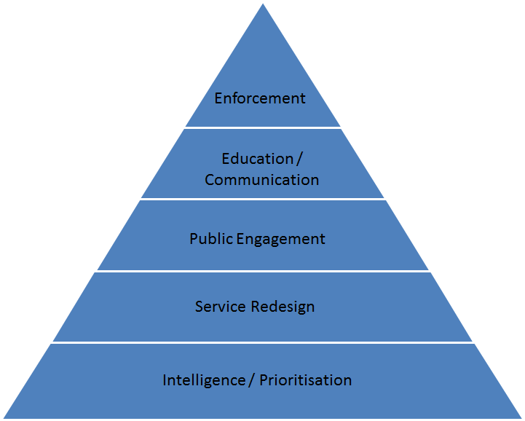

2.7.3 This approach looks at identifying what the issues are and where, based on intelligence gathered from data the council holds including complaints, feedback, crime data etc. This allows to understand how the service should then be set up to tackle these identified issues (for example, more bins needed in a certain area, night time cleaning). Once completed, the public are then engaged to get them to be part of the solution, with all stages supported by a clear communication and education strategy. Enforcement is the last stage, tackling the persistent, entrenched and / or criminal elements.

2.7.4 The Council also conducted a Lean Review of Fly Tipping which examined the fact that an intelligence led approach is best taken, hitting the areas of main concern and clearing the other areas without delay

2.7.5 As a result of the above, a Fly Tipping Operational Plan is being developed to take into account all partners, the best means to approach tackling the issue, enforcement options, use of CCTV and Drones and the communications around this.

2.7.6 A fundamental aspect of this will be to decide the Corporate Approach to Private and Unadopted / Orphaned (no legal owner) land which is currently approached in an ad hoc approach, with some being cleared by the Council and some not.

2.7.7 Intelligence is the best way forward to identify causation and key areas of concern. In light of this, work is currently taking place between the Community & Public Protection and the London Fire Brigade to map out areas of concern. An example of this is provided in Appendix 3

2.7.8 Ultimately, Enforcement is one aspect of tackling the issue and a better partnership approach is required. This is being explored further as part of an ongoing Enforcement Review.

# 

# 2.8 Communication and Education

2.8.1 Good communication is integral to any strategy, and key to influencing behaviour change around making fly tipping an unacceptable activity and one not engaged in by members of communities. This must consist of a clear communication strategy built around local level consistent and clear messages.

2.8.2 Such a strategy must take into account all relevant parties including households, private landowners, property landlords, business owners and communities to tackle fly-tipping together. Messages must be around the aspect of fly tipping being a crime but also educating in terms of their ‘duty of care’ and how they can dispose of waste safely, legally and responsibly.

2.8.3 There is not one means of communications, but be across a range of media from relevant local papers, websites, social media and use of Council and partner assets such as adverts on Council vehicles. It must be aimed at ensuring that the message is constantly prominent and recognised by all, and simple and directed enough to cut across language barriers. Where specific research shows a specific community group in the hot spot(s) being targeted, the communications message must be relevant enough, be it through language or example, to have an impact.

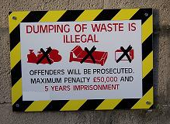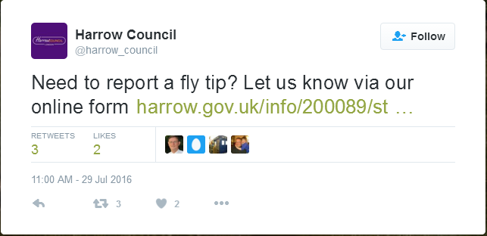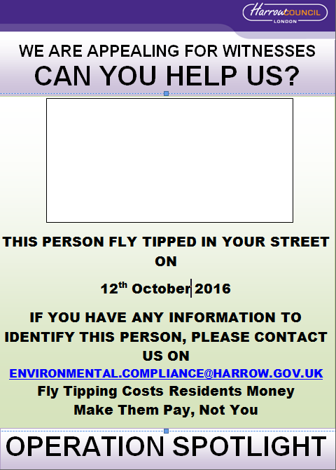

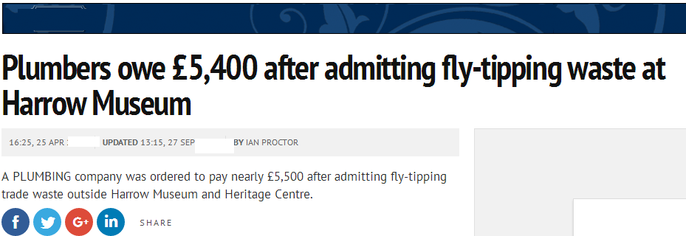

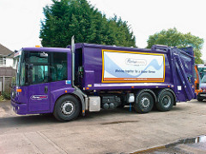

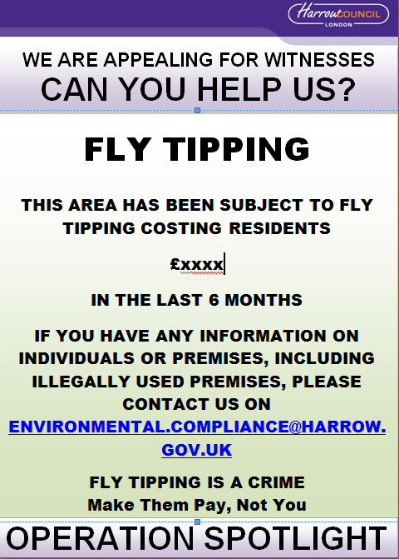

1. **Financial Implications**

3.1 There are no financial implications associated with this report

1. **Performance Issues**

3.2 There are no performance issues associated with this report

1. **Environmental Impact**

5.1 By its very nature, fly tipping is a blight on the environment and therefore is of primary concern. It is the reason it remains one of the key areas of the Administration to address.

1. **Risk Management Implications**

Risk included on Directorate risk register? No

Separate risk register in place? No

1. **Equalities implications**

Was an Equality Impact Assessment carried out? No

The report is for information only and therefore has no EQIA impacts

1. **Council Priorities**

The Council’s vision:

**Working Together to Make a Difference for Harrow**

Please identify how the report incorporates the administration’s priorities.

* Making a difference for the vulnerable
* Making a difference for communities
* Making a difference for local businesses
* Making a difference for families

Section 4 - Contact Details and Background Papers

**Contact:** Richard Le-Brun, Head of Service (Community & Public Protection), 020 8424 6267, Richard.lebrun@harrow.gov.uk

**Background Papers:**

Fly Tipping: Causes, Incentives and Solutions, Jill Dando Institute of Crime Science 31 May 2006

Working Better Together, Fly-Tipping Protocol 6, 2005

Defra, Fly capture fly-tipping national database background

<http://keepbritaintidy.org/Documents/Files/Campaigns/stakeholders_litter_report_FINAL_web.pdf>

http://www.tacklingflytipping.com/Documents/NFTPG-Files/Jill-Dando-report-flytipping-research-report.pdf

1. Fly Tipping: Causes, Incentives and Solutions, Jill Dando Institute of Crime Science 31 May 2006
2. http://cebcp.org/evidence-based-policing/what-works-in-policing/research-evidence-review/broken-windows-policing/
3. Working Better Together, Fly-Tipping Protocol 6, 2005
4. Defra, Fly capture fly-tipping national database background
5. http://www.tacklingflytipping.com/Documents/NFTPG-Files/Jill-Dando-report-flytipping-research-report.pdf
6. http://keepbritaintidy.org/Documents/Files/Campaigns/stakeholders_litter_report_FINAL_web.pdf